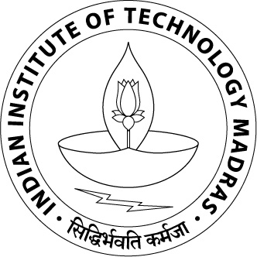
Name | Roll no.
Indian Institute of Technology Madras

EDUCATION
Program | Institution | %/CGPA | Year of completion
Dual Degree in Electrical Engineering | Indian Institute of Technology Madras, Chennai | /10 |  | 2018
STD XII |  | 83.4% |  | 2012
STD X |  | 91.17% |  | 2010

SCHOLASTIC ACHIEVEMENTS

COURSE WORK

LABS

Skills

PROjects
- Project 1 (Nov14-Present)

- Project 2 (Nov13-Mar14)

- Project 3 (July17-Present)

- Course Projects

PROFessional Experience
1. (May2016-july2016)

2. (Nov2016-Dec2016)

Positions of responsibility
1. (Sep14-Jan15)

2. (Jan14-Mar14)
3. (July17-Present)

Co-curricular & Extra-curricular activities

